Male Urinal

Code: TOI 062 (from TCES)
Bed Pan

Code: TOI 069 (from TCES)
Slipper Pan

Code: TOI 065 (from TCES)
Female Urinal

Code: TOI 064 (from TCES)

Areas covered | Contact Details
South East Shropshire | Base Contact Details:  Tel: 01743 444062  Continence Service  Shropshire Rehabilitation Centre  Lancaster Road  Shrewsbury  Shropshire  SY1 3NJ
North West Shropshire Shrewsbury and Atcham
North East Shropshire
Telford and Wrekin
South West Shropshire
Service Operational Hours
Monday – Friday 08.30-16.30

V3 06/01/2026 Continence Aid Booklet

Shropshire’s

Continence Advisory

Service


Continence Aid
Booklet

Please be aware of manufacturer’s guidance when issuing these products.
Vernagel — FP10
Order Code:322-9184—box of 100 sachets.

To request a sample pack from: Verncare
Call: 01204 529494
www.vernacare.com
Bioderm – FP10

Bioderm XLS sheath
Pack of 10 Code: 20026/10

For Samples visit www.mypelvichealth.co.uk
& search Bioderm
Conveen- FP10
Optima
For samples call Coloplast: 0800 374654
www.coloplast.co.uk

Clear Advantage & Clear advantage with Aloe- FP10

For Samples call scripteasy 08000121699
www.bardmedical.co.uk
Uri bag Male – FP10

Code: URIbag male

0870 190 4100
www.manfred-sauer.co.uk

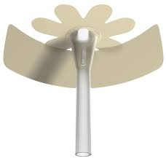

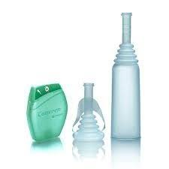

Faecal Collector — FP10
500mls (box of 10) code: 9822
1000mls (box of 10) code: 9821

For samples call Hollister :
Ben Rep 07701351735
www.hollister.co.uk
Retracted Penis Pouch – FP10
(box of 10) Code: 9873

For samples call Hollister :
Ben Rep 07701351735
www.hollister.co.uk
Acti-Brief Plus - FP10

For samples call Bullen on 0800 888501
www.bullens.com
Beambridge- Bridge urinal with Tap – FP10

Code: 6-18T
www.beambridgemedical.com
Beambridge Funnel – FP10
Code:
Male: 6-35, Short: 6-37, Youth: 6-38
Female: 6-40

www.beambridgemedical.com

