Male Urinal

Code: TOI 062 (from TCES)
Bed Pan

Code: TOI 069 (from TCES)
Slipper Pan

Code: TOI 065 (from TCES)
Female Urinal

Code: TOI 064 (from TCES)

Advisor | Contact Details
Jemma Brown  Continence Team leader  South East Shropshire | Base Contact Details:  Tel: 01743 444062  Shropshire Community Health NHS Trust  Halesfield 6  Halesfield  Telford  Shropshire  TF7 4BF
Fiona Glover
North West Shropshire Shrewsbury and Atcham
Susan Southern
North East Shropshire
Nicola Head/ Jenny Henderson
Telford and Wrekin
Val Proctor/ Andrea Davies
South West Shropshire

Service Operational Hours
Monday – Friday 08.30-16.30

V2 06-2021 Continence Aid Booklet

Shropshire’s
Continence Advisory
Service



Continence Aid
Booklet

Please be aware of manufacturer’s guidance when issuing these products.
Vernagel — FP10
Order Code:322-9184—box of 100 sachets

To request a sample pack from: Verncare
Call: 01204 529494
www.vernacare.com
Bioderm – FP10

Bioderm XLS sheath
Pack of 10 Code: 20026/10

For Samples visit www.mypelvichealth.co.uk
& search Bioderm
Conveen- FP10
Optima
For samples call Coloplast: 0800 374654
www.coloplast.co.uk

Clear Advantage & Clear advantage with Aloe- FP10

For Samples call scripteasy 08000121699
www.bardmedical.co.uk
Uri bag Male – FP10

Code: URIbag male

0870 190 4100
www.manfred-sauer.co.uk

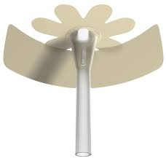

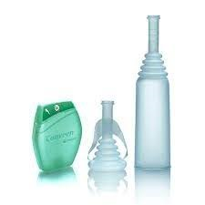

Faecal Collector — FP10
500mls (box of 10) code: 9822
1000mls (box of 10) code: 9821

For samples call Hollister :
Ben Rep 07701351735
www.hollister.co.uk
Retracted Penis Pouch – FP10
(box of 10) Code: 9873

For samples call Hollister :
Ben Rep 07701351735
www.hollister.co.uk
Anal Plugs – FP10
Small (box of 20) Code: 1450
Large (Box of 20) Code: 1451

For samples call Coloplast: 0800 374654
www.coloplast.co.uk
Acti-Brief Plus - FP10

For samples call Bullen on: 0800 888501
www.bullens.com
Beambridge- Bridge urinal with Tap – FP10

Code: 6-18T
www.beambridgemedical.com
Beambridge Funnel – FP10
Code:
Male: 6-35, Short: 6-37, Youth: 6-38
Female: 6-40

www.beambridgemedical.com

