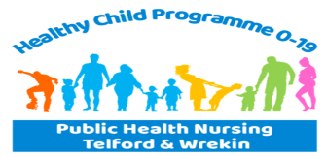
Healthy Child Programme 0 -19 Service
14 Leonard Street
Oakengates
Telford
Shropshire
TF2 6EU
Telephone: 0333 358 3328

Healthy Child Programme
0-19 Service e-referral Form

Child or young person being referred
First Name: |  |  | Last Name:
Date of Birth: | Gender: |  |  | NHS No:
Address:
Postcode: |  | Contact Phone No:
School/Nursery/Childminder:

EHA/EHSP/CP/CiN/LAC/SEND/OTHER Please indicate if applicable

This referral has been discussed and agreed by parent/guardian/carer /young person
Date:

All persons with parental responsibility

Name and relationship to child: | Name and relationship to child:
Address and contact details: | Address and contact details:

Reason for referral Please tick all relevant

Physical
Emotional
Development concern
Maternal low mood
Sleep
Behaviour
Feeding/weaning
Accident prevention
Sexual Health
CSE
Diet
Weight
Communication

Support required:

Known medical conditions including disability

Does the child/young person have any communication?
Difficulties ?
Interpreter required?

Details of person making the referral

Name: Contact Tel No.

Agency: Job Title:

Signature: Date:

For Telford Public Health Nursing Service 0-19 only:
Allocated to:
Date referral received:
Action taken :

Acknowledgement receipt sent
Allocated to Family First
Allocated to Community First
Declined referral response sent

Added to MTP CF/FF Please circle if relevant

Please email completed referral form to shropcom.adminleonardst@nhs.net

