Services for Children’s and Families

Children and Young People’s Speech and Language Therapy Service

Children and Young People Pre-School Referral Form

Please ensure you complete all relevant areas of the form fully to avoid delay and assist us in processing this referral. Thank you.
We can provide some general information or advice to you without a re-referral through our advice line - on 01743 450800 (Option 4)

Has the child/young person been seen by our service within the last 12 months:

If Yes: Please call our Admin Team on 01743 450800 (Option 4) to request an appointment for our Advice Line Team. You will be able to discuss your reasons for re-referral and possible next steps. Should you only need access to previously completed Training Package/s for a new staff member working with a child, please let our Admin Team know so this can be actioned.

If No: Please continue with this form

- If you have concerns about any of the following, please go straight to the *REFFERAL FORM:
- Eating, drinking or swallowing difficulties
- Stammering / stuttering
- Selective Mutism
- Voice
- Early Years Complex Needs (EYCN) – these children are generally known to the Community Paediatric Service. The Health Visiting team may have identified them as having two or more areas of concern identified on the Ages and Stages Questionnaire (ASQ). The Team supporting these children are based at the two Child Development Centres.
Please see our website for more information: www.shropscommunityhealth.nhs.uk/childrenspeechlanguagetherapy

- If you have concerns about Speech, please access the SLT website: https://www.shropscommunityhealth.nhs.uk/chslt-speech-sounds and look at ‘Use of speech sounds at a developmentally appropriate level’ and ‘What to look for’ in order to decide if a referral is needed.

As children develop their speech and language skills, it is important to think about their understanding of language, their talking (using words and sentences) and their speech (speaking clearly).

If you are still concerned about speech, please complete this *REFFERAL FORM along with the completed ‘Mini Speech Screen’.

- If you are a Parent / Carer – please call 01743 450800 (Option 4) to make an Advice Line appointment – do not complete this form.

Referral Criteria for Settings:
- You must complete a screening tool for one of the following interventions and follow the referral criteria for your chosen screening (please see referral flow chart in Appendix A)

- Talk Boost, WellComm, NELI, Stoke Speaks Out
- The difficulties identified must be out of line with the child / young person’s overall level of development or be having a significant impact beyond what would be expected by their level of learning and cognition.

Referral Criteria for Health Visitors:
- Please see referral information in Appendix B1

Have Parents / Carers and the child been informed about this referral and have they signed the box in Section C to indicate this? Yes ☐ No ☐

Please provide information relating to your re-referral below

*REFERRAL FORM:
A. Child’s Details
Child’s Full Name:
Date of Birth: |  |  | NHS No:
Resident address and Post Code:
Additional details
Parent’s/Carer’s Name(s):

Mobile Tel no:
Home Tel no:
Email address:
Other Parent/Carer name and address (if different from child):

Mobile Tel no:
Home Tel no:
Email address:
Name of Parent/Carer(s) with parental responsibility:

The child / young person  - Is a Looked After Child  - Has a child protection plan?  - Has a disabilities plan?  - Identified as SEND Support?  - Has an EHCP? | Yes ☐ No ☐ Don’t Know ☐  Yes ☐ No ☐ Don’t Know ☐  Yes ☐ No ☐ Don’t Know ☐  Yes ☐ No ☐ Don’t Know ☐  Yes ☐ No ☐ Don’t Know ☐
Home Languages |  | Interpreter needed Parent: Yes ☐ No ☐  Interpreter needed Child: Yes ☐ No ☐
GP address and contact details

Other professionals and contact details

B. Referral Details
Does the child have any diagnoses? |  |  | Yes ☐ No ☐ Don’t Know ☐
Diagnoses given

Information about the Intervention:  (please see Appendix A for information) |  |  | Name of Intervention (e.g. NELI, TalkBoost, etc.). |  | Score on the initial  Screen  i.e. Red / Amber | Number of  times intervention completed |  | Score on  follow-up screen  i.e. Red / Amber
Briefly describe why are you referring this child and what you want the outcome of our involvement to be?

For the child:
Observations / Responses in Play / Expressive Language Sample / Speech Sounds Sample
What kind of help are you providing already in your setting?

Some children have speech difficulties which are not expected during development.

These include (please indicate ‘yes/no’ as appropriate):
- Over 3 years old and parent/carer cannot understand most of the time. YES / NO
- Over 3 years old and less than 5 different consonant sounds produced on the Mini Speech Screen. YES / NO
- Over 3 years old and often does not repeat the words when asked (check words with a dash (-) on the Mini Speech screen). YES / NO
- Over 4 years and new people cannot understand most of the time. YES / NO
- Over 4 years old and does not repeat p, t, c/k, f, s accurately as single sounds. YES / NO
- Over 4 years and often did not say the words on their own (check words marked with an asterisk (*) on the Mini Speech Screen). YES / NO
- Any age and always misses sounds off at the beginning of words, e.g. 'food', - 'ood', 'duck' - 'uck'. YES / NO
- Any age and always changes sounds to c/k or g, e.g. 'two' - 'coo', 'sea' - 'key', 'ball' - 'gall'. YES / NO

For concerns re Stammering / Stuttering, please complete the checklist (see Appendix C)

For your Staff/ the child’s family: e.g. Access to training. Please describe any training in SLCN the lead people supporting the child have:

What advice have you given to the Parents / Carers?

FOR HEALTH VISITORS REFERRALS ONLY (ONCE YOU HAVE SEEN THE CHILD) – REFER IF CHILD IS: (tick those relevant according to the child’s age)
Age 0 – 11 months
☐Speech Sounds and Talk – Not making or playing with speech sounds at 10 months – e.g. no babble or any vocalisations heard
☐Social Skills and Use of Language – Not sensing different emotions in carers voice and responding differently (questioning, laughing, smiling etc) by 12 months

Age 8 – 20 months
☐Attention and Listening – Does not concentrate intently on an object or activity of own choosing for increasing periods of time by 20 months
☐Understanding of Language – Does not recognise or point to objects or pictures in books if asked by 18 months, e.g. when asked ‘What is that?’
☐Talking – Does not use 10 single words (may not be clear) at 20 months
☐Social Skills and Use of Language – Does not use simple pretend play e.g. pretending to feed toys, pretending to put toys to bed etc. by 20 months

Age 16 – 27 months
☐Understanding of Language – Does not understand simple instructions containing 2 key words without clues by 24 months e.g. ‘Put the toy on the chair’ and ‘Put the spoon in the cup’ and ‘Put the hat on the table’
☐Talking – Does not begin to combine 2 to 3 simple words by 36 months e.g. “mummy go car” and ‘I eat apple’

Speech – Cannot be understood by familiar adult by 36 months – see above section re speech development

Age 22 – 36 months
☐Attention and Listening – Cannot switch attention to a different task shift to a if when requested by an adult at 36 months, e.g. attention remains single channelled only
☐Understanding of Language – Cannot demonstrate understanding of language linked to early concepts by 36 months e.g. ‘show me the big cup’, ‘put teddy under the table’ and sometimes colours, e.g. ‘give me the red sock’
☐Social Skills and Use of Language – Not interested in others play and does not join in at 36 months, e.g. child prefers to play alone

Age 30 – 50 months
☐Talking – Does not use complex sentences at 48 months. Not linking 2 ideas with ‘and’, ‘because’ e.g. “I go on bus and see Grandma”, “I like the park ‘cos’ I go on swings”

Age 40 – 60 months
☐Understanding of Language – Doesn’t understand questions containing sequencing words by 60 months e.g. “what did you do after lunch?”

EVIDENCE IN SUPPORT OF REFERRAL
Observations / Responses in Play / Expressive Language Sample:

What kind of activities / strategies have already been tried?

What advice have you given to the Parents / Carers?

FOR SETTING / SENCO REFERRALS ONLY:
Please include any recent relevant reports, including from LSATS / Eps, school based assessments academic achievements profiles. Our usual practice is to ask you to follow at least one specific piece of advice related to SLCN from these reports for two terms before considering referring to SLT for further detailed assessment. The talking point website has a progress checking function http://www.talkingpoint.org.uk/Parent/Directory/Progress-Checker.aspx
Please indicate your comparison between the child’s speech, language and communication and other areas of learning or development

C. Informed
- Under the General Data Protection Regulation (GDPR) we are required to inform our patients and service users of how their information will be used. We have done this through a Privacy Notice which is available on the Shropshire Community Health Trust Website: https://www.shropscommunityhealth.nhs.uk/.

I ______________________________________________ (parents/carers full name) agree that my child, identified above, can be referred to the Children’s Speech and Language Therapy Team. I have been made aware of the Shropshire Community Trust Privacy notice.

- I (parents/carers) agree to receiving correspondence / documents by email.

Preferred email address: ______________________________________________

Parents/Carers signature___________________________________ Date_________________

- Children are usually offered a clinic appointment for initial assessment. Would you
foresee any difficulties with regard to attendance (e.g. transport / childcare difficulties) YES / NO

- Please indicate if you would like to be informed of the date of the child’s initial appointment YES / NO

D. Referrer Contact Details
Referrer Name

Job Title |  |  |  | Dept / Organisation
Referrer Address
Referrer Tel No. |  |  |  | Mobile No.
Referrer Email
Date of Referral
E. Setting Details (if different from Section D)
Name of setting
Full Address
(Inc. postal code)

Tel No.
Contact email address
SENCO & contact person e.g. Keyworker or TA supporting the child

Thank you for completing this form.

Please return via Secure Email to: shropcom.childtherapyreferrals@nhs.net

Speech and Language Therapy Advice Line

We are offering a telephone advice service for Parents, and Education staff in Shropshire and Telford and Wrekin to answer:

- General queries without a referral for example about:
  - Whether a referral or re-referral to the service is needed
  - Sourcing equipment or activity ideas related to speech and language interventions

- Specific queries about an individual child or young person’s needs or development, which will require a referral
Please contact us via Telephone: 01743 450800 (Option 4)

Collecting information about your ethnic group

In order to help the NHS understand the needs of patients and service users from different groups and to comply with the Race Relations (Amendment) Act 2000, we need to collect information about your child’s ethnic group. This information will be treated confidentially and will not be shared with any other organisation.

Everyone belongs to an ethnic group. By collecting this information the NHS will be able to identify those groups more at risk of specific diseases and their care needs and so provide better, and more appropriate services for you and your family.

The attached list of 16 ethnic groups are the standard categories. Using these codes will help us to compare information about the groups using our services and assist us in providing for our local population.

It is important that where possible your child is able to describe their own ethnic group. If this is not possible, then parents/carers should enter this information on behalf of their child.

Thank you for taking the time to provide this useful information.

Name: _______________________________ DOB: __________________ NHS no: ____________________

Ethnic group
What is your ethnic group? Choose ONE section from A to E, then tick the appropriate box to indicate your ethnic group
A: White
¨ British
¨ Irish
¨ Any other White background (please write in)
B: Mixed
¨ White and Black Caribbean
¨ White and Black African
¨ White and Asian
¨ Any other Mixed background (please write in)

C: Asian or Asian British
¨ Indian
¨ Pakistani
¨ Bangladeshi
¨ Any other Asian background (please write in)

D: Black or Black British
¨ Caribbean
¨ African
¨ Any other Black background (please write in)

E: Chinese or other ethnic group
¨ Chinese
¨ Any other (please write in)

Referral Criteria for Settings Appendix A

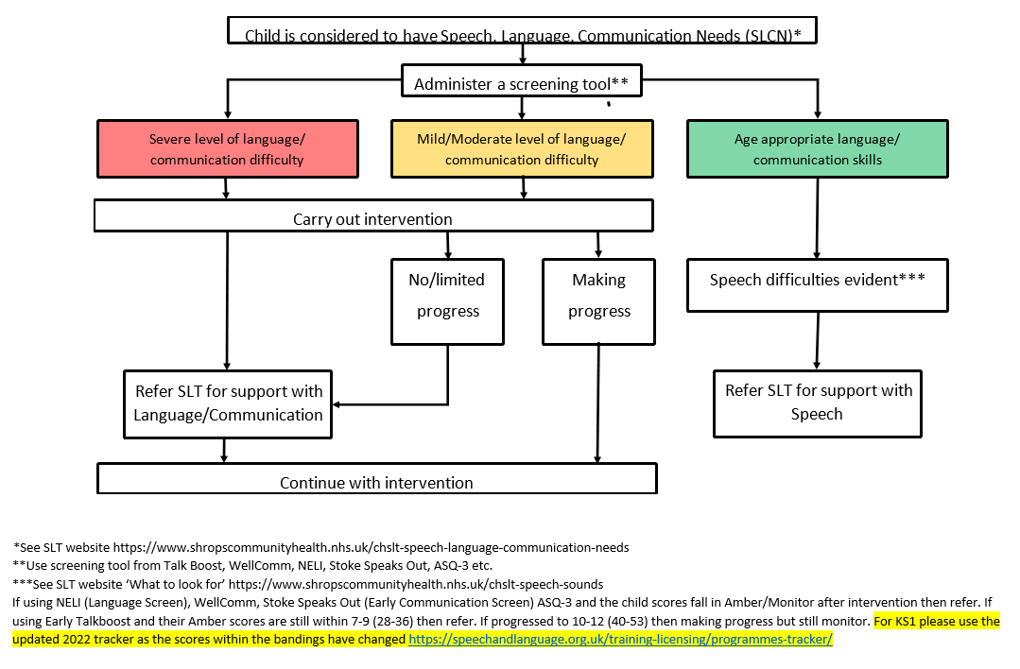

Health Visiting Team Referral to SLT Service Appendix B1

- If a Parent/Carer report concerns through SPOA they can be directed to SLT Advice Line 07143 450800 (Option 4) and signposted to the SLT website: www.shropscommunityhealth.nhs.uk/childrenspeechlanguagetherapy

- Following a Face to Face visit:
- Please use the specific Health Visitor tick box section to indicate the reason for referral
- Please also include any relevant observations of the child / language samples / strategies already tried / advice
given to parents / carers
- Appendix B2 can be used to track the child’s development in more detail and can be helpful to share with parents /
carers if required

- Following a Face to Face visit and ASQ completed:

- Mild/moderate level of language/communication difficulty indicated (i.e. language & communication section of the ASQ)
→ see above

→ if the child is 3 years and above, and is attending a Setting or Childminder, request them to complete an Early Years Talk Boost screen (or equivalent) and follow Referral Flow Chart (Appendix A)

- Severe level of language/communication difficulty indicated, with 2 or more sections of the ASQ below the expected level
→ Refer to Community Paediatrician AND refer to SLT using this online *REFERRAL FORM

- Speech difficulties evident - see SLT website ‘What to look for’ www.shropscommunityhealth.nhs.uk/chslt-speech-sounds

Early Speech and Language Development Chart Appendix B2

Stage and age | Attention and listening | Understanding of language | Speech Sounds And Talk | Social skills and use of language
0-11 months  The Early Communicator | - Turns towards a familiar sound  - Startled by loud sounds  - Watches face when someone talks | - Recognises parent’s voice  - Understands frequently used words such as “all gone”, “no”,” bye-bye”  - Stops and looks when hears own name | - Communicates in a variety of ways - gurgling, crying, babbling  - Plays with speech sounds (bababa) > 10 | - Reaches out and points  - Makes vocal sounds to get attention  - Tries to copy adult speech and lip movement  - Takes turns in conversations using babble  - Senses different emotions in carers voice and responds differently (quietening, laughing, smiling etc) > 12
8-20 months  First Word User | - Locates source of voice with accuracy  - Pays attention to dominant stimulus  - Enjoys music and singing  - Concentrates intently on an object or activity of own choosing, for increasing periods of time. > 20 | - Gives named objects to adult (e.g. book, apple, car)  - Understands simple instructions (“kiss Mummy”, “where’s your nose”, “stop”)  - Recognises and points to objects, or pictures in books if asked > 18 | - Babbling in strings of connected but different sounds ba-ba-no-no-go-go  - Reaches out or points to objects while making speech sounds  - Uses around 10 single words although they may not be clear > 27 | - Uses gestures such as waving and pointing with eye gaze to make requests and share interests > 18 and consider referral to community Paediatrician  - Plays alone but likes to be near familiar adult  - Responds to words and interactive rhymes such as “clap hands”  - Uses simple pretend play e.g. feeding teddy > 20
16-27 months  Combiner | - Responds to an adult talking and briefly shifts attention from something they are doing to the speaker  - Recognises and responds appropriately to many familiar sounds e.g. a knock on the door | - Understands 200-500 single words including some actions  - Understands simple instructions, containing 2 key words without clues, e.g..‘Make the teddy sleep’, from a choice of two characters and two actions after demonstrating a similar task > 27 | - Uses up to 50 words  - Begins to combine two or three simple words > 36 complete Talk Boost  - Begins to ask simple questions (“where’s my drink?”)  - Can be understood by familiar adult > 36 Complete Talk Boost + mini speech screen | - Pretend play developing with toys (feeding a doll or talking on telephone)  - Follow adult body language including pointing, gesture and facial expression
22-36 months  Early sentence user | - Listens with interest to the noises adults make when they read stories  - Single channelled attention, can shift to a different task if attention is first gained by adult > 36 complete Talk Boost | - Understands who, what, where questions (but not why)  - Identifies action words by pointing to the right picture e.g. “who’s jumping”  - Demonstrates understanding of the language linked to early concepts including ‘in/on/under’,  ‘big/little’ > 36 Complete Talk Boost | - Uses a wide range of words including descriptive language, time, space and function/action  - Links 4-5 words together  - Able to use pronouns (me, him, she)  - Able to use prepositions (in on under)  - Starting to use word endings (‘ing’, ‘s’)  - Can be mostly understood by strangers > 48 Complete Talk Boost + mini speech screen | - Can take several turns in a conversation but jumps from topic to topic  - Expresses emotion to adults and peers using words not just actions  - Has some favourite stories, songs and rhymes  - Uses language to share ideas and experiences  - Interested in others play and will join in > 36 complete Talk Boost
Talk Boost screen will be required from 36 months:
30-50 months  Later sentence user | - Enjoys listening to stories  - Can shift attention between listening to others and doing own activity without adult prompt. Anticipates and joins in with familiar actions and phrases in rhymes and stories | - Understands use of objects (“what do we use to cut things?)  - Shows understanding of prepositions (behind, in front)  - Aware of time in terms of today, yesterday, tomorrow | - Uses talk to connect ideas and explain what is happening  - Asks lots of why questions  - Can retell a simple past event in correct order  - Using more complex sentences > 48 | - Understands turn-taking as well as sharing with adults and peers  - Initiates conversations  - Enjoys playing with peers  - Able to argue with adults or peers if they disagree – uses words not just actions
40 -60 months  Skilled Communicator | - Sustains attentive listening, responding to what they have heard with comments, questions or actions  - Maintains attention, concentrates and sits quietly when appropriate  - Two channeled attention- can listen and do at the same time | - Able to follow a simple story without pictures  - Understands questions containing sequencing words (what did you do after tea?) > 60  - Understands and enjoys rhyme  - Laughs at simple jokes  - Understands adjectives (soft, hard etc)  - Demonstrates understanding of how and why questions by giving explanations > 72 | - Easily understood by adults and peers  - Mostly uses well formed sentences  - Uses complex linking words appropriately, (‘and’, then’, because’) | - Chooses own friends  - Generally co operative with playmates  - Able to plan construction and make-believe play activities  - Takes longer turns in conversations  - Maintains theme/topic of conversation  - Uses language to organise sequence and clarify thinking  - Introduces a storyline to their play

Pre-Five Stammering Checklist Appendix C

Please tick all that apply:-

☐You or parent/s observe that the child shows signs of stammering

Please describe the stammer:

☐There is a family history of stammering

☐You or the parents think that the child is finding learning to talk difficult in any way

☐The child is showing signs of being upset or frustrated about his speaking

☐The child is struggling when talking

☐The child is in a dual language situation and stammering in his first language

☐There is parental concern or uneasiness

☐The child’s general behaviour is causing concern

