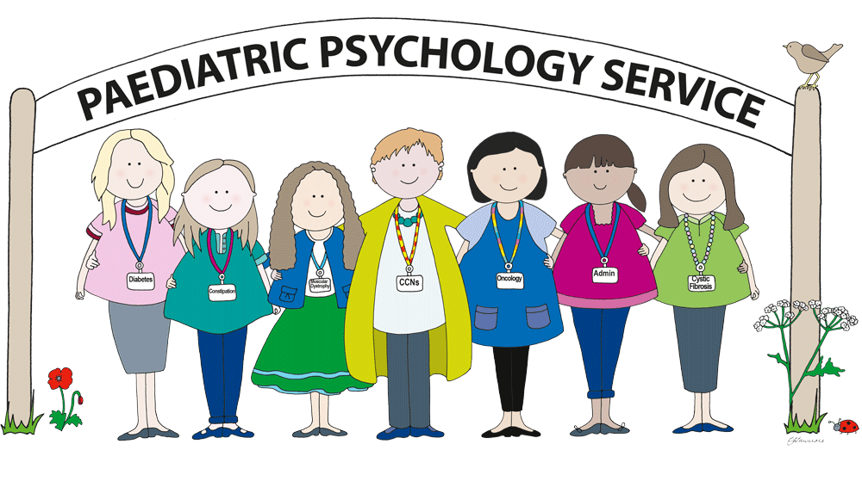
DIRECTIONS TO MONKMOOR CAMPUS PAEDIATRIC PSYCHOLOGY
We are based in the building called:
Multi-Agency Child and Family Support Service

Our address is:

Psychology Suite, Monkmoor Campus, Woodcote Way, Shrewsbury, SY2 5SH

The entrance is between the Severndale School and Wilfred Owen School. It has a green arrow marking it:
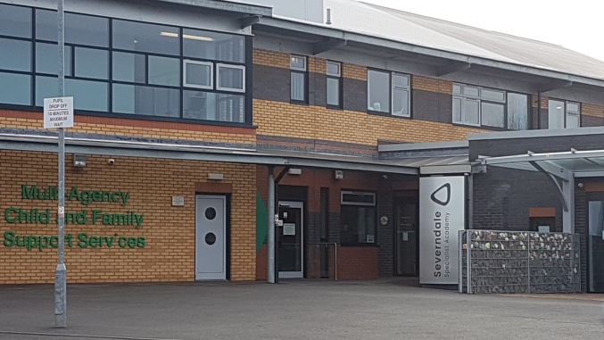
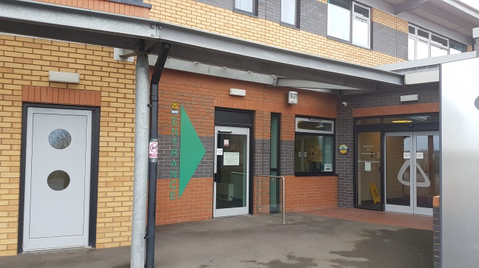

Directions to the Centre

From the M54:
Follow signs for the A49 and Harlescott Park and Ride. Pass Tescos on the right hand side and go straight on through the traffic lights. At the Heathgates roundabout, take the second exit towards Monkmoor. At the next roundabout, take the first exit to Monkmoor. At the traffic lights, turn left into the car park for the centre.

From Shrewsbury Town Centre:
Leave Shrewsbury by the English Bridge along Abbey Foregate. Turn left at the first set of traffic lights along Monkmoor Road. Keep going until you reach the Police Station roundabout. Take the first exit into Woodcote Way. Pass the pedestrian crossing and turn right at the traffic lights into the centre car park.

Buses and Trains:
The nearest train station is Shrewsbury. The number 11 bus runs twice an hour from Barker Street bus station (Stand D) up to the Police Station which is within walking distance of the centre. It takes about 10 minutes. For more travel details call Traveline on 0871 200 2233.
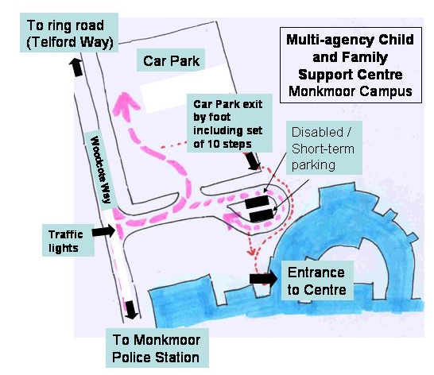

When you arrive you will be directed to our waiting area upstairs (lift or stairs):

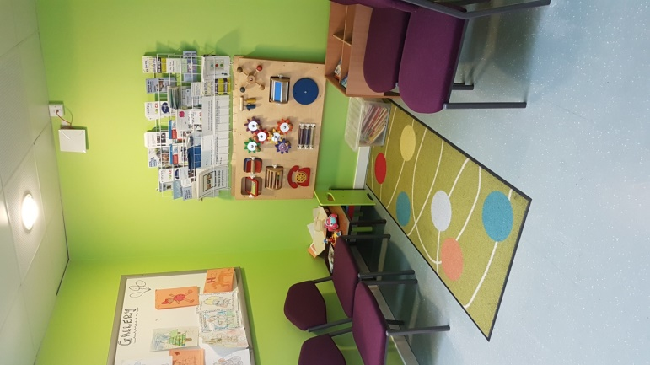
If you are seen at Monkmoor we have a room available to meet families in which looks like this: (please note, you may be seen in another room shared with other services at particularly busy times)
