Expenses Guide – Claimants

Log in to expenses
- In your web browser enter the address: www.sel-expenses.com.
- Click the Go button or hit enter on your keyboard.
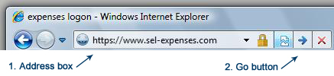
- The expenses logon page will appear and you can log into the system by entering SCHT as the Company ID, and your Username (assignment number) and Password in the text fields provided.
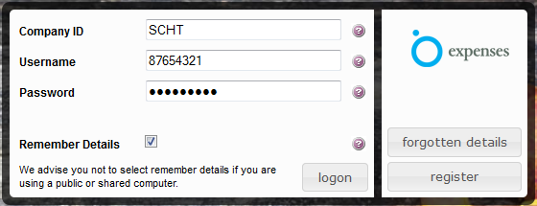
- Click the logon 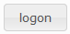 button (or press the enter key).

Adding New Expense Items
All expense items are added through the Add / Edit Expense page. This is accessed by clicking Add New Expenses from the Welcome page.
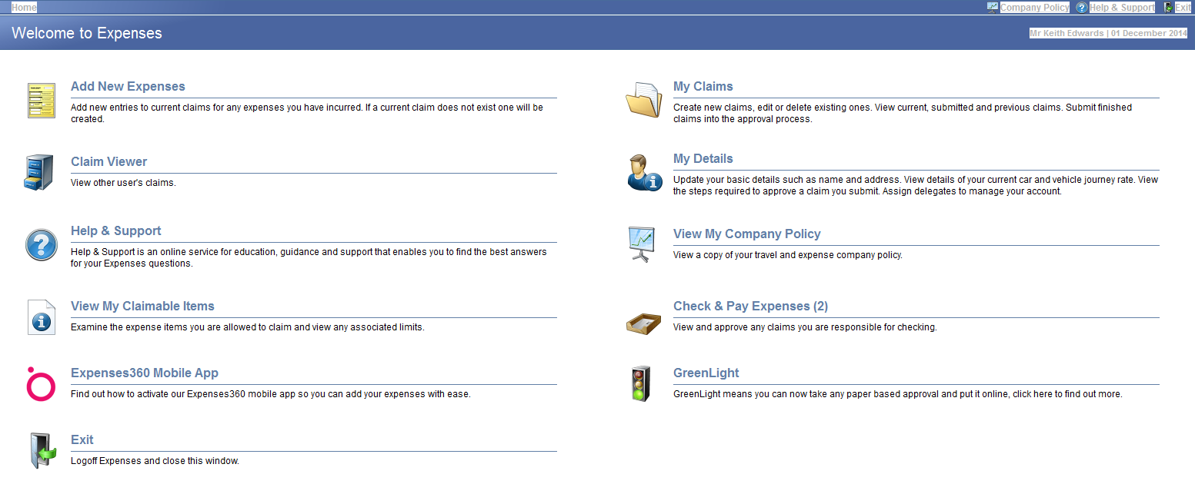
You will then be presented with the Add / Edit Expense page:
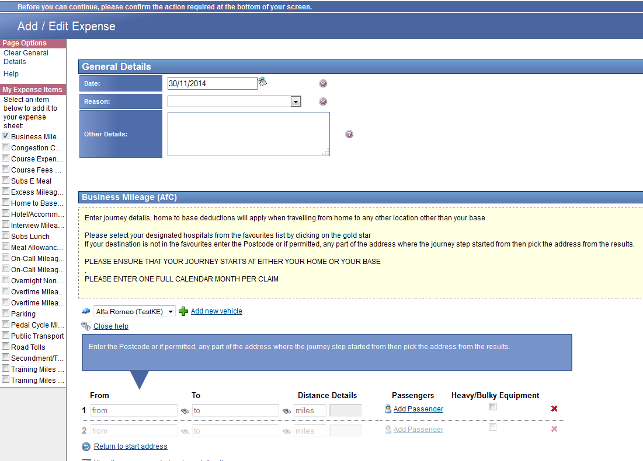
Please follow these steps to enter your expense items:
- Set the date - expenses defaults in the current date, where appropriate you can change this by either selecting from the calendar or overtyping the current date.
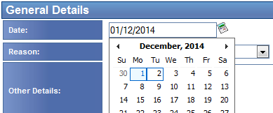
- Select a reason - for your journey from the drop down box by clicking on the down arrow
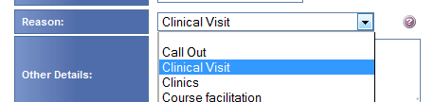
- Add a narrative - In the other details box add any further narrative to explain to your approver the reason for incurring expenses.
- Check what type of expenses you are adding – checking an item in the left hand list adds it to the body of the claim.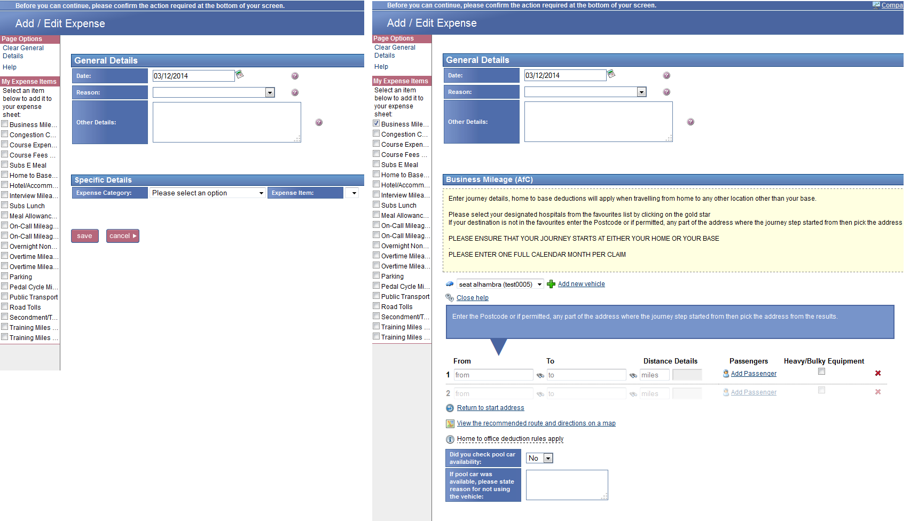
You should always check the heading of each section to ensure you are claiming for the correct type of expense as in each case the grid layout is identical.
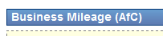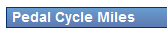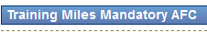
Once you have checked an expense item it will appear on subsequent claims, to remove it simply un-check it on the left hand list. For this reason it is important you claim the right expense type, business miles, cycle miles and non-mandatory training miles are all paid at different rates.
- Enter trip details – expenses will load the expense item “Business Mileage” by default. Click in the ‘From’ box and start to type a post code or address name
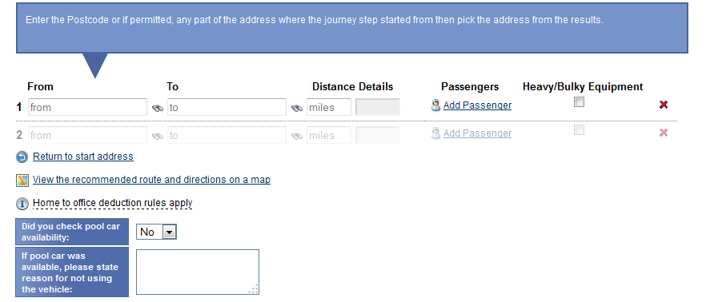
Expenses will list addresses with favourites at the top, so frequently used and Trust sites such as William Farr House will appear;
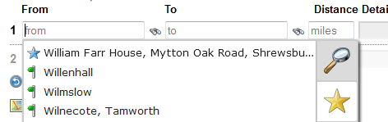
Also, at the bottom of this tab are shortcuts to your home and base addresses
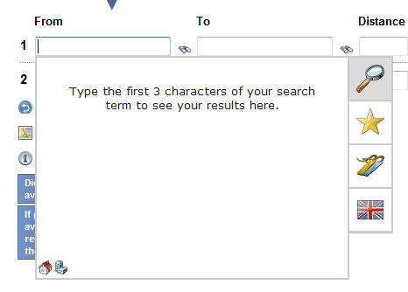
Click either and expenses will automatically populate the from/to field with the appropriate address
- Complete your journey – the second stage of your journey will automatically fill in the “From” box based on the “To” box from your previous journey. Regardless of the number of stops all journeys should start and end at either home or base.
- Add any passengers – if appropriate add other trust staff who were a passenger by clicking the Passengers link,
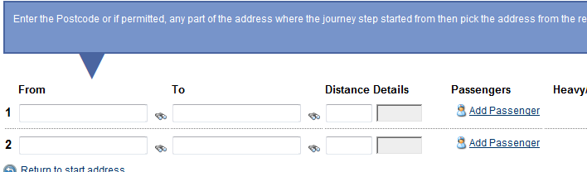
Type in the name of the passenger in the format first name then surname. In the example below you can see the list being revised by the inclusion of the first letter of the surname.
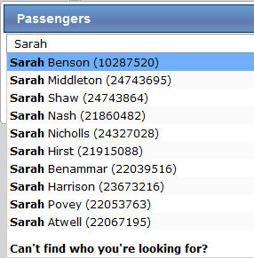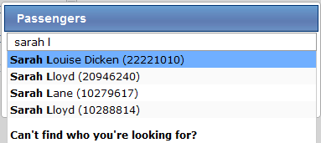
If you have a passenger who is employed by another NHS organisation you are also eligible to claim passenger miles for them. Click “Can’t find what you are looking for” and add their name and Organisation.
- Other items to claim? - a list of all the expense items you are able to claim for is available on the left hand side of the page under the My Expense Items menu.
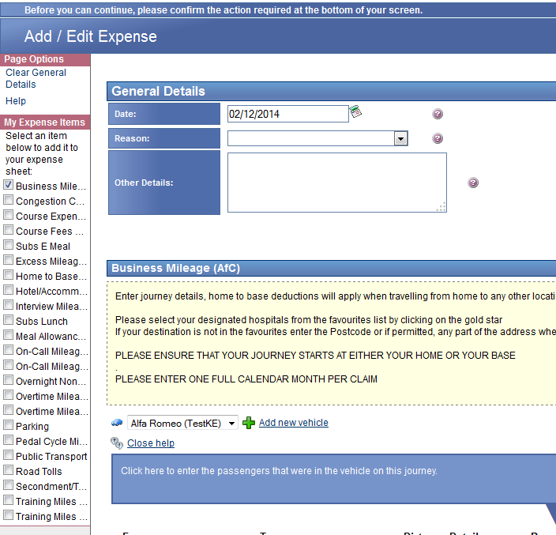

Simply select the check box next to each item you need to reclaim, this will refresh the page to display the relevant fields you must complete that are associated with each item. Within each expense item certain fields may be mandatory for completion and will be identified by an asterisk (*) after the field name.
- Complete - all the required information for each expense item; you can find further information on what you need to enter by clicking the tooltip icon.
Please note: If you add several expense items at once (mileage, hotel and parking for example), the general details entered will be saved against each of those items.
- Save - when you reach the bottom of the screen click the save button and your items will be added to your expense account.
- Summary - You will now be returned to your Current Claims screen which lists of all your current expense items. At this point you can still edit or delete these items or add a receipt
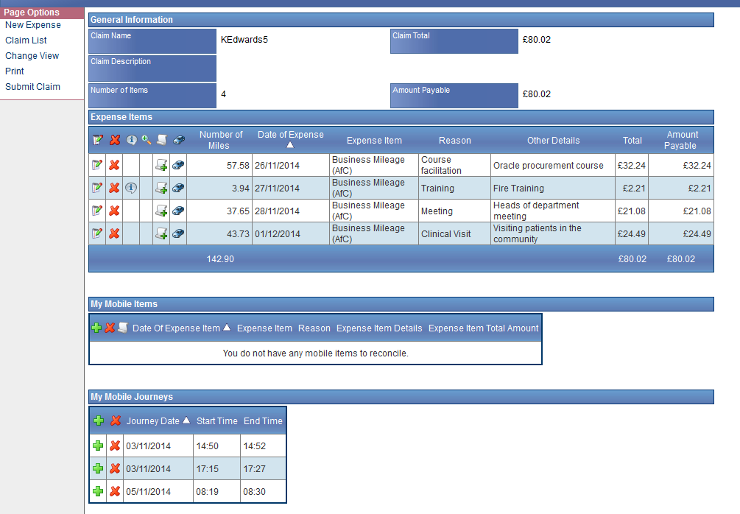

- Add - further days expenses by clicking the “New expenses” link at the top left hand side of the page or log out when finished.
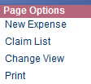
- Important: Your expenses claim form has not yet been submitted for approval at this stage. You should continue to add expenses throughout the month until submitting your claim as normal. **Do not submit each item as you add it, you may only submit one claim per month**
Submitting your claim at the end of the month
- From the Welcome page click My Claims,

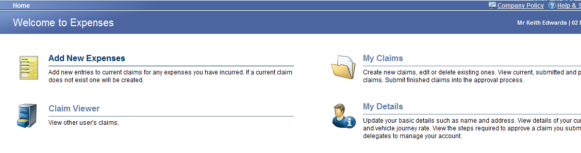
- Then click Current Claims.
- Click Submit Claim from the Page Options menu which can be found on the left hand side of the screen.
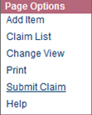
- These page options are also displayed after you have added an expense item.
Please note: You can add expense items from different days, business trips, events or activities to one claim. Expense claims should be submitted at least every six months and always at the end of a financial year (31st March).
- Lease car users - are required to enter the odometer reading. Enter your current odometer reading for each car that is activated within the system into the New Odometer Reading box.
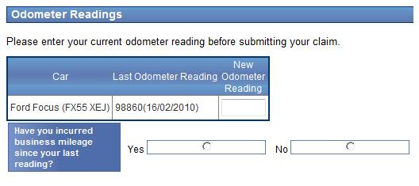
Click the save button and your new odometer reading will be submitted.
- The next screen will display the name and description of the claim.
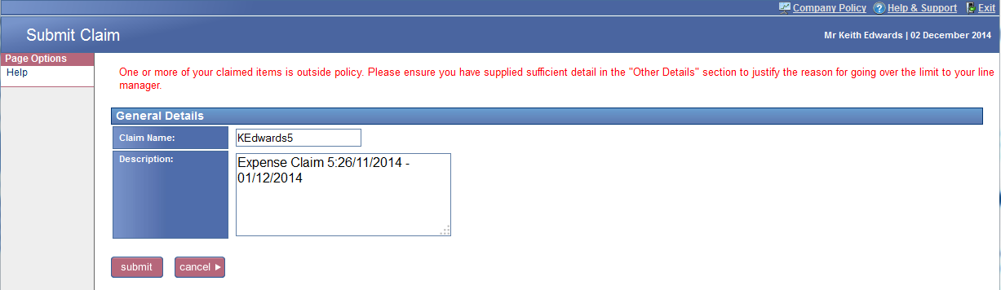

- Flagged Items - at this stage if any of your expense items have been flagged you will be presented with a message above the general details of the claim. Click the cancel button if you wish to return to your claim. If you are happy that you have provided sufficient detail click 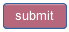
- Complete - any required changes if you clicked cancel, then click the button.
- Declaration – read and accept the declaration confirming that the information you have entered is correct. If your claim is accurate, click the I Accept link. Your claim will now be submitted in to the approval process.
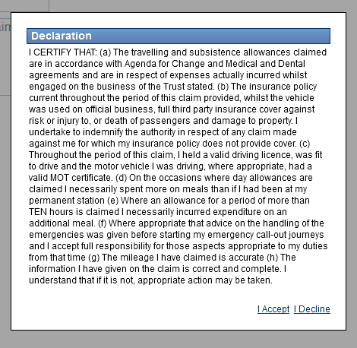
Once your claim has been submitted it will be sent to your next line manager who has authority to approve travel expense claims. Unless the claim is returned, in which case you will be notified by e-mail, you will not be required to take any further action. You can check the progress of your submitted claims by clicking My Claims from the Welcome page and then clicking Submitted Claims.
Un-submit a claim
You may have submitted your claim and overlooked an item. You can add this to your next claim but as expenses only allows you to submit one claim per month if you want to claim for this in the current month you will have to un-submit your current claim. Under my claims select the submitted claims link
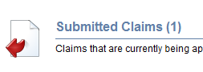
And under page options click un-submit claim
