
CONT 027
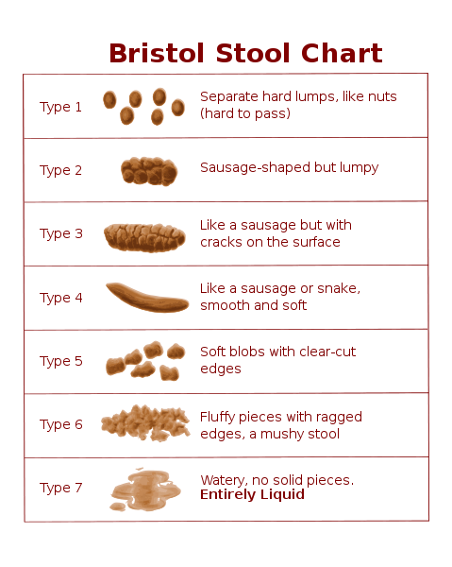
BOWEL DIARY

INSTRUCTIONS FOR USE

(This is page1 of 2. Page 2 is your bowel diary to complete.)

Please complete the diary and have it available for your appointment.
It is important that you provide as much information as possible,
as this will form part of your clinical assessment.
Your assessing nurse will discuss this diary with you at your next appointment.

The length of time for which you need to complete the diary, will be recorded
at the top of the diary by your assessing nurse.

Please refer to and use the Bristol Stool Scale (BSS).
A copy of this will be given to you by your assessing nurse if you do not already have access to this.

Fill in each column every time you have your bowels opened.

EXAMPLE
DATE | TIME | Number of days since bowels last opened | BSS | Did you get the feeling you needed to have your bowels opened? | Length of time spent on the toilet | Amount passed  Small  Medium  Large | Did you need to strain a lot?  Yes / No | Did you get any pain?  Yes / No | Did you leak any stools before you reached the toilet?  Yes / No | Any bowel medication taken? What and when did you take it. | Any bowel emptying techniques used?
June 25th | 10am | 4 | 2 | Yes | 15 minutes | Small | Yes | No | No | No | No
June 28th | 4 pm | 3 | 2 | Yes | 10 minutes | Medium | Yes | Yes | No | No | No

BOWEL DIARY

FULL NAME: ________________________ Date of Birth : ________ NHS No: ______________ Diary Sheet No_____

(This is page 2 of 2. See page 1 for instructions on completion.)
Please complete the diary recording all your bowel movements for the next____weeks/days.
Please refer to the Bristol Stool Scale (BSS).
DATE | TIME | Number of days since bowels last opened | BSS | Did you get the feeling you needed to have your bowels opened? | Length of time spent on the toilet | Amount passed  Small  Medium  Large | Did you need to strain a lot?  Yes / No | Did you get any pain?  Yes / No | Did you leak any stools before you reached the toilet?  Yes / No | Any bowel medication taken? What and when did you take it. | Any bowel emptying techniques used?
Chart completed by: (name and signature)…………………………………………………………………………………………………………………
Chart seen by assessor and outcomes discussed (name, signature, date) …………………………………………………………………………

