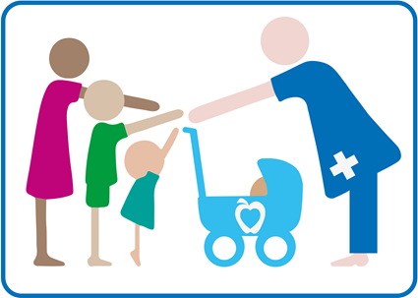
Healthy You, Healthy Future
Public Health Nursing Service Referral Form
Please return to:
SPOA, Shropshire Public Health Nursing Service, Coral House, 11 Longbow Close, Harlescott Lane, Shrewsbury, SY1 3GZ.
shropcom.spoa@nhs.net
Parent: 0333 3583654
Professional: 01743 730090
Child or Young Person being referred:

Full Name:…………………………………… Date of birth/EDD: .…./.…./…..
NHS No.:……………………………………... Gender: Male / Female / Unspecified
Home Address:………………………………………………………… Post Code:………........
Educational Setting:………………………………………………………...
Please confirm Parent/carer/young persons consent has been obtained (please cross out those that do not apply) Yes □ No □
Parents/ Carer details:
Name: |  |  | Contact phone No:
Person(s) making the referral:
Name/Agency: |  | Contact Number:
Brief reason for referral:

Signature: |  |  | Date:

Date referral received: | Allocated to:
Referrer notified:

