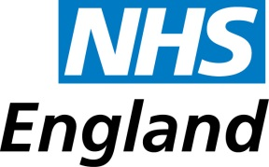
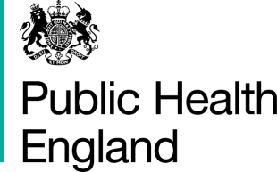

Tuesday 23rd February 2016

Dear Colleague,

Men B immunisation programme

Following the recent media coverage about the death of a young girl from invasive meningococcal disease caused by Men B, many practices have had queries from parents about availability of Men B immunisation. We are writing to confirm the national position, and respond to some of the questions that have been asked.

This information is taken from Public Health England publications and the GOV.UK website (see below for details).

What is the national policy for Men B immunisation?
The Men B immunisation programme started on 1 September 2015 for babies aged 2 months, i.e. babies born on or after 1 July 2015. There was a limited catch-up programme for babies born on or after 1 May 2015. The routine schedule is for immunisation to be given at 2 and 4 months with the primaries, with a booster at 12 months.

Delivery of the Men B immunisation programme in our locality is in line with national policy.

Can I vaccinate children born before 1 May 2015 if parents request it?
No. The national stock of Bexsero® should only be used to vaccinate children who are eligible for NHS vaccination.

Can I vaccinate children born on or after 1 May 2015 who have not yet been vaccinated?
Yes. All children in the eligible cohort (i.e. born on or after 1 May 2015) remain eligible for Men B immunisation until the age of two years. When Bexsero® has not been given as part of a primary course, give two doses at least two months apart. Those children who have received one dose before their first birthday only require one more dose. Please see the Men B PGD for more information.

If parents ask to pay for Men B immunisation for their children, what should I tell them?
GPs should not charge their own patients (i.e. those registered at their practice) a private fee for the vaccine.

Parents seeking the vaccine privately should be made aware that they will be liable for the full costs of the vaccine and any additional administration charges that the private provider may apply. We understand that GSK has supply constraints on the Bexsero vaccine for the private market. Practices must not use centrally-procured stock for the national programme to vaccinate private patients or any patients

outside the eligible cohort (other than those at high risk as defined in the green book).

We do not hold any information about local private vaccination providers.

I hope that this helps with your queries.

Yours sincerely,

Screening and Immunisation Team
Public Health England

Further information

- There is general information about MenB immunisation on the NHS Choices website:
http://www.nhs.uk/conditions/vaccinations/pages/meningitis-b-vaccine.aspx

- There is information for parents and professionals about MenB immunisation on the GOV.UK website:
https://www.gov.uk/government/collections/meningococcal-b-menb-vaccination-programme

- Immunisation against meningococcal B disease for infants aged from two months. Information for healthcare professionals.
https://www.gov.uk/government/publications/meningococcal-b-vaccine-information-for-healthcare-professionals

- The Green Book chapter 22
https://www.gov.uk/government/publications/meningococcal-the-green-book-chapter-22

- The MenB PGD (your practice should have a copy of the PGD).

- Questions and Answers: Immunisation against meningococcal B disease for infants aged from two months
https://www.gov.uk/government/publications/meningococcal-b-vaccine-information-for-healthcare-professionals

